­­­

SE / ComS 319

Construction of User Interfaces

May 7, 2024

Edmund Lim, [elim655@iastate.edu](mailto:elim655@iastate.edu)

Dallas Kuiper, [dmkuiper@iastate.edu](mailto:dmkuiper@iastate.edu)

Ali Jannesari, Ph.D.

Final Project Documentation

1. **Final Project Description**

**Introduction**

LiveTix is designed to revolutionize the way concert tickets are sold and managed. Motivated by the cumbersome and often confusing ticket purchasing experiences currently prevalent, our project aims to simplify and enhance the user’s journey from ticket discovery to purchase, using modern web technologies. Our platform addresses issues such as slow loading times, poor mobile experience, and unclear user interfaces that are common with existing ticketing solutions.

**Objectives**

● **Enhance User Experience:** Create a user-friendly, intuitive, and responsive web

interface.

● **Streamline Ticket Purchasing:** Simplify the process of finding, selecting, and

purchasing tickets.

● **Improve Data Management:** Utilize MongoDB for efficient data handling and

transactions.

● **Provide Real-Time Updates:** Ensure ticket availability and event information are up to date.

1. **Software Functionality Diagram**

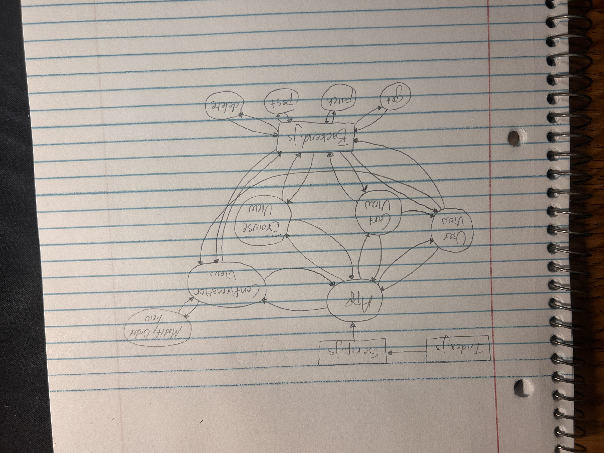

1. **Files and Directory Architecture**

This is the main Web page. On this page you can see along the top a search bar to search for any tickets for any artists you would like to perchase. In the top right corner, you will see a green browse button, a cart button, and a person icon. These buttons along with the search bar will always be visible. The browse button will return you to this Web page. The cart button will bring you to the cart view to view your selected items as well as a place to enter your information to complete the order. The person icon button will bring you to a page wher you can look up a previous order.

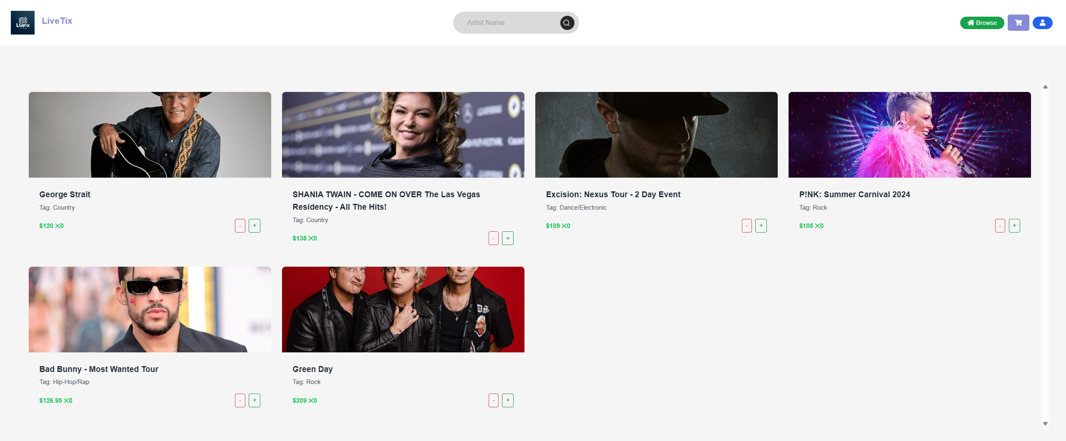

This is the cart view. You can see the items you have selected as well as other fields where you can enter information to process your order

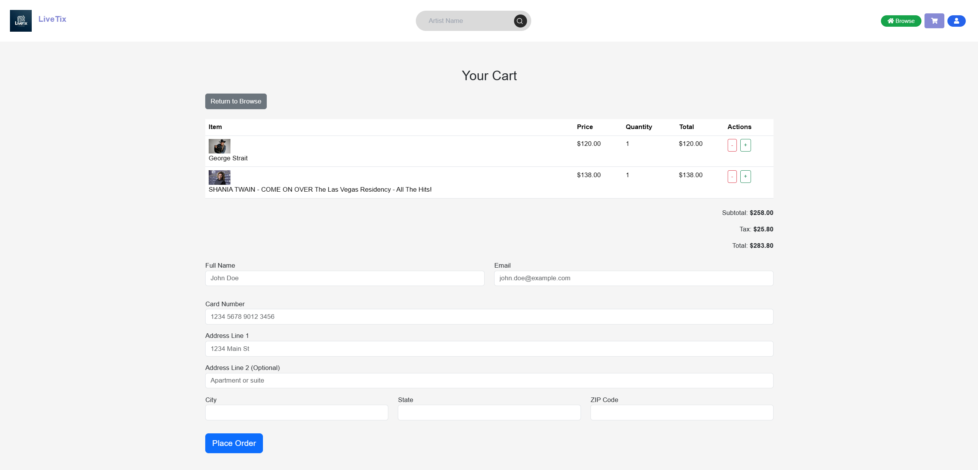

This is wher you can look up a previous order you have made by entering the email used as well as the confirmation number.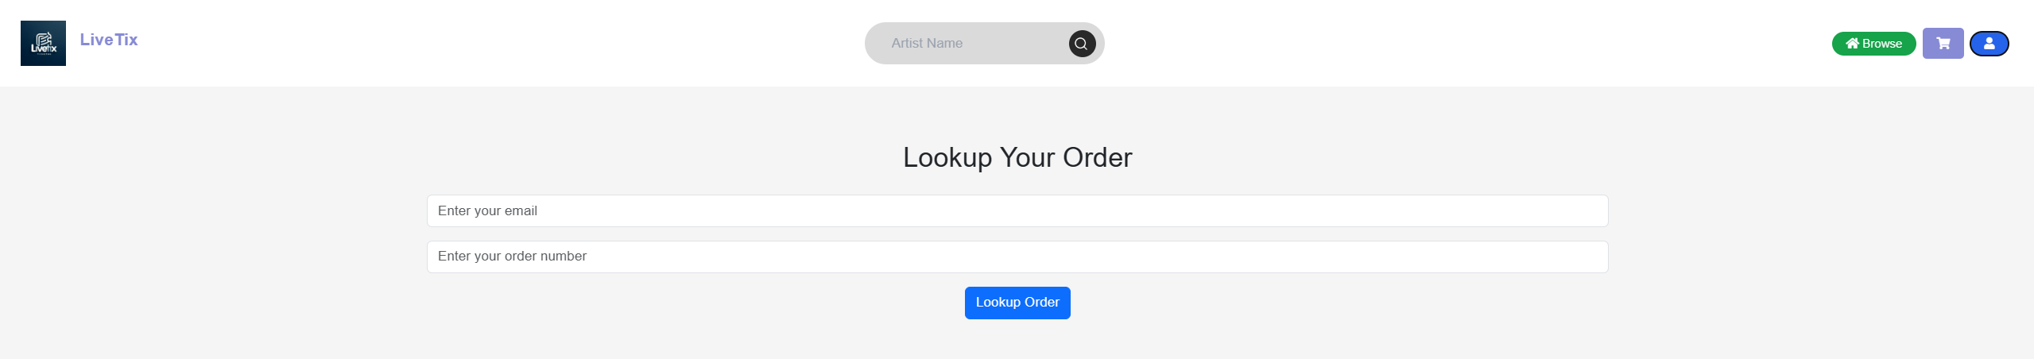

This is the order confirmation view. You can see the information you have entered to process your order as well as the contents of the order and the order confirmation number.

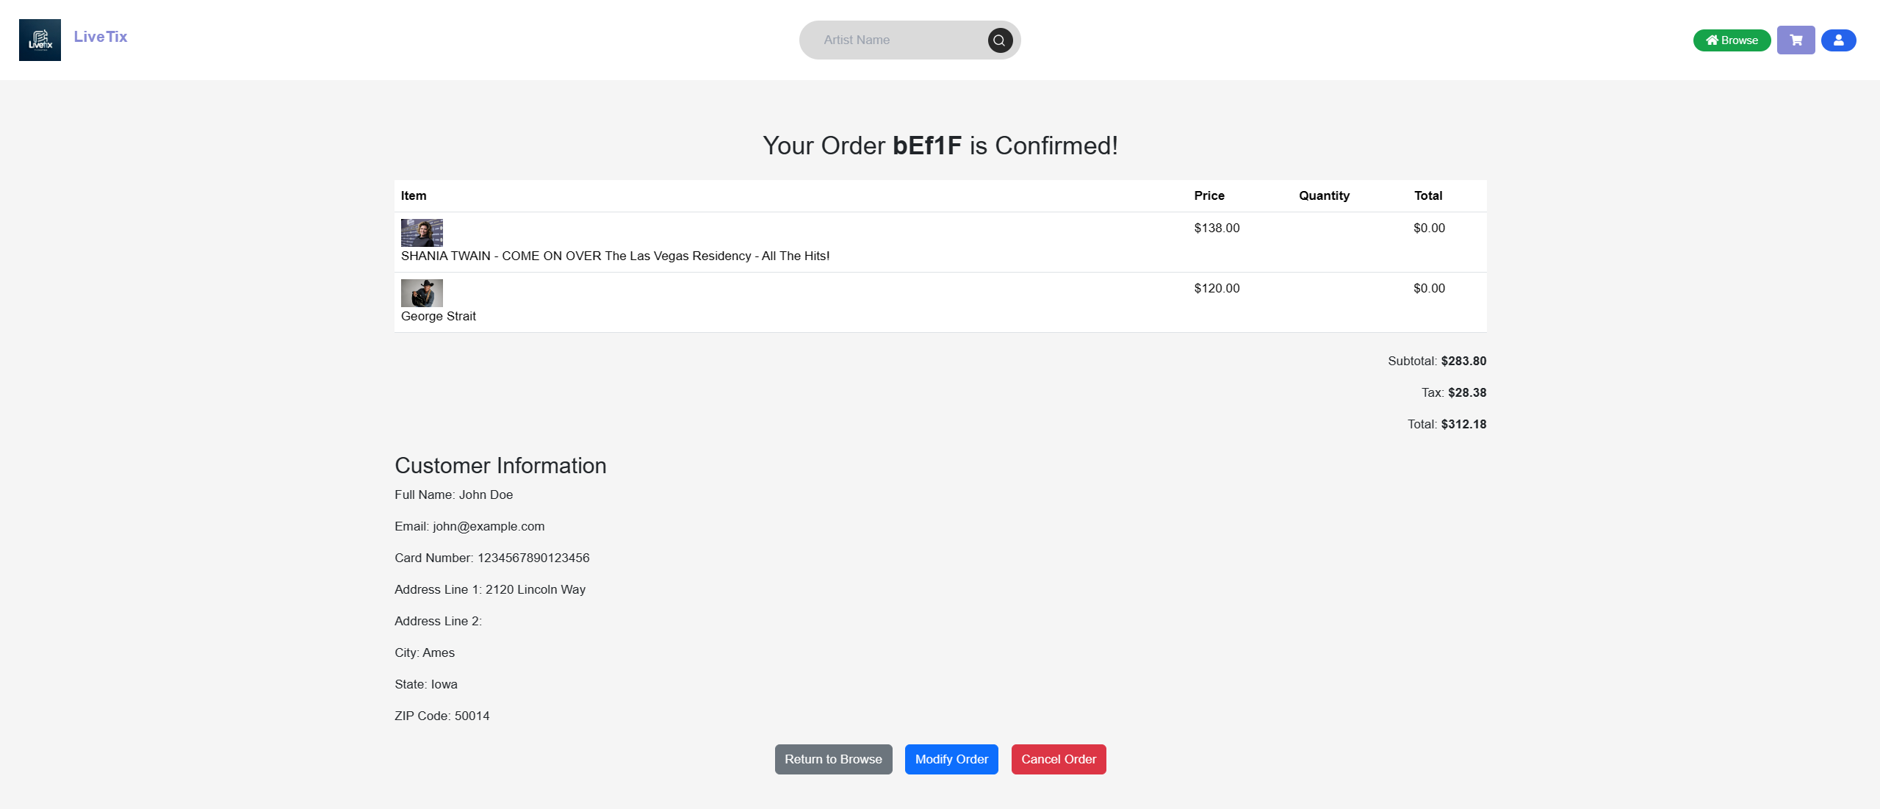

This is where you can modify the information you entered for a previous order made.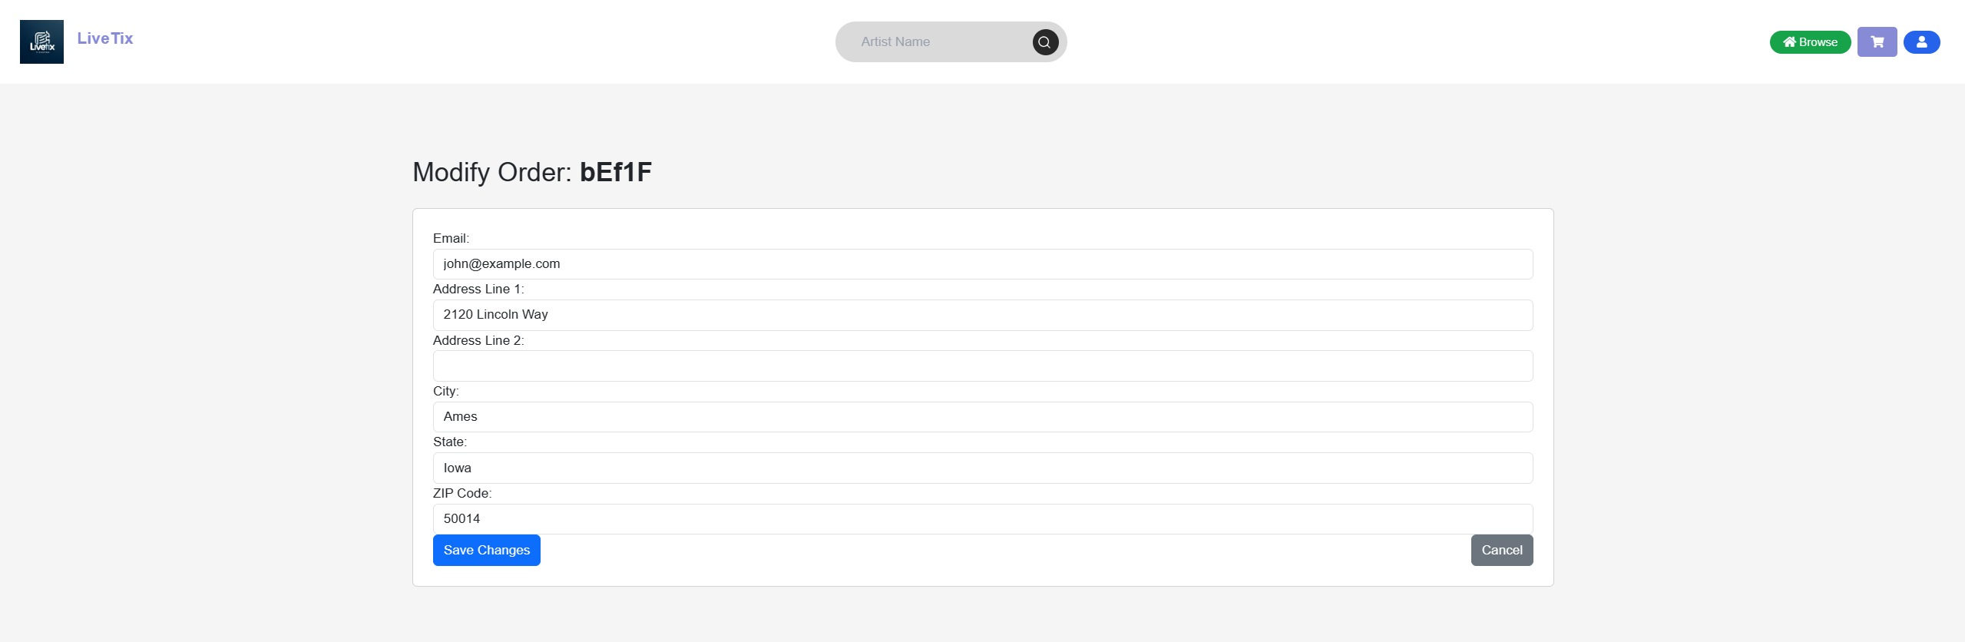

1. **Installation Manual**

After downloading our project from git, you must run ‘npm install’. This should install all the applications to run the webpage along with running the backend. If you would like to interact with the database and run API calls, you must download MongoDB. After downloading you must create a database named ‘FinalProject’ with two collections, ‘LiveTix’ and ‘Orders’. Once everything is downloaded, you must cd into the ‘livetix’ folder and run ‘npm start’. In another terminal, cd into ‘livetix/src’ and run the command ‘node backend.js’. LiveTix should now be running on your device!

1. **Copy of Code**

index.js

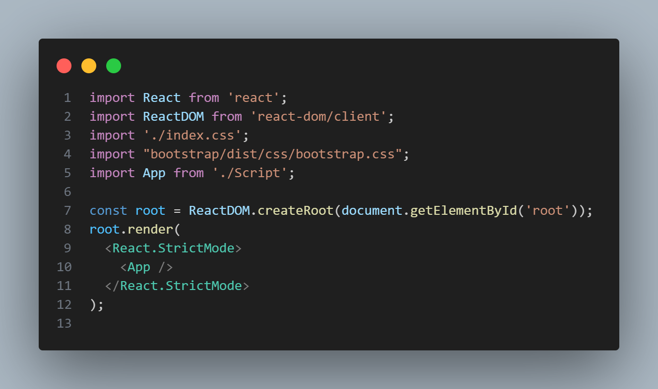

backend.js

const express = require("express");

const cors = require("cors");

const bodyParser = require("body-parser");

const { MongoClient } = require("mongodb");

function generateOrderNumber(length) {

    let result = '';

    const characters = 'ABCDEFGHIJKLMNOPQRSTUVWXYZabcdefghijklmnopqrstuvwxyz0123456789';

    const charactersLength = characters.length;

    for (let i = 0; i < length; i++) {

        result += characters.charAt(Math.floor(Math.random() * charactersLength));

    }

    return result;

}

var app = express();

app.use(cors());

app.use(bodyParser.json());

const port = "8081";

const host = "localhost";

// MongoDB

const mongoUrl = "mongodb://127.0.0.1:27017";

const dbName = "FinalProject";

const client = new MongoClient(mongoUrl);

app.listen(port, () => {

    console.log(`App listening at http://${host}:${port}`);

});

app.get("/products", async (req, res) => {

  try {

      await client.connect();

      const db = client.db(dbName);

      const collection = db.collection("LiveTix");

      const products = await collection.find({}).toArray();

      res.status(200).json(products);

  } catch (error) {

      console.error("Failed to retrieve products:", error);

      res.status(500).json({ message: "Failed to retrieve products." });

  } finally {

      await client.close();

  }

});

// Fetch a single product by id

app.get("/products/:id", async (req, res) => {

    const { id } = req.params;

    try {

      await client.connect();

      const db = client.db(dbName);

      const collection = db.collection("LiveTix");

      const product = await collection.findOne({ id: parseInt(id) });

      if (!product) {

        return res.status(404).json({ message: "Product not found." });

      }

      res.status(200).json(product);

    } catch (error) {

      console.error("Failed to retrieve product:", error);

      res.status(500).json({ message: "Failed to retrieve product." });

    } finally {

      await client.close();

    }

  });

// Route to handle new order creation

app.post("/orders", async (req, res) => {

    const order = req.body;

    order.orderNumber = generateOrderNumber(5); // Generate a unique order number

    try {

        await client.connect();

        const db = client.db(dbName);

        const collection = db.collection("Order");

        const result = await collection.insertOne(order);

        if (result.acknowledged) {

            res.status(201).json({ message: "Order placed successfully", orderId: result.insertedId, orderNumber: order.orderNumber });

        } else {

            throw new Error("Failed to insert order");

        }

    } catch (error) {

        console.error("Failed to place order:", error);

        res.status(500).json({ message: "Failed to place order.", error: error.message });

    } finally {

        await client.close();

    }

});

// Route to get order by order number

app.get("/orders/:orderNumber", async (req, res) => {

    const { orderNumber } = req.params;

    try {

        await client.connect();

        const db = client.db(dbName);

        const collection = db.collection("Order");

        const order = await collection.findOne({ orderNumber: orderNumber });

        if (!order) {

            return res.status(404).json({ message: "Order not found." });

        }

        res.status(200).json(order);

    } catch (error) {

        console.error("Failed to retrieve order:", error);

        res.status(500).json({ message: "Failed to retrieve order.", error: error.message });

    } finally {

        await client.close();

    }

});

// Update an existing order

app.patch("/orders/:orderNumber", async (req, res) => {

    const { orderNumber } = req.params;

    const updates = req.body;

    delete updates._id;

    try {

        await client.connect();

        const db = client.db(dbName);

        const collection = db.collection("Order");

        const result = await collection.updateOne({ orderNumber: orderNumber }, { $set: updates });

        if (result.matchedCount === 0) {

            return res.status(404).json({ message: "No order found with that order number." });

        }

        if (result.modifiedCount === 0) {

            return res.status(200).json({ message: "Order found but no updates made." });

        }

        res.status(200).json({ message: "Order updated successfully" });

    } catch (error) {

        console.error("Failed to update order:", error);

        res.status(500).json({ message: "Failed to update order.", error: error.message });

    } finally {

        await client.close();

    }

});

// Delete an existing order

app.delete("/orders/:orderNumber", async (req, res) => {

    const { orderNumber } = req.params;

    try {

        await client.connect();

        const db = client.db(dbName);

        const collection = db.collection("Order");

        const result = await collection.deleteOne({ orderNumber: orderNumber });

        if (result.deletedCount === 0) {

            return res.status(404).json({ message: "No order found with that order number." });

        }

        res.status(200).json({ message: "Order cancelled successfully" });

    } catch (error) {

        console.error("Failed to cancel order:", error);

        res.status(500).json({ message: "Failed to cancel order.", error: error.message });

    } finally {

        await client.close();

    }

});

// Lookup an order by email and order number using path parameters

app.get("/orders/lookup/:email/:orderNumber", async (req, res) => {

    const { email, orderNumber } = req.params;

    console.log("Received request to lookup order with email:", email, "and order number:", orderNumber);

    try {

        await client.connect();

        const db = client.db(dbName);

        const collection = db.collection("Order");

        const order = await collection.findOne({

            email: decodeURIComponent(email),

            orderNumber: decodeURIComponent(orderNumber)

        });

        if (!order) {

            return res.status(404).json({ message: "Order not found." });

        }

        res.status(200).json(order);

    } catch (error) {

        res.status(500).json({ message: "Failed to lookup order.", error: error.toString() });

    } finally {

        await client.close();

    }

});

// Search products by name

app.get("/products/search", async (req, res) => {

    const { query } = req.query; // Get the search query from URL parameters

    try {

        await client.connect();

        const db = client.db(dbName);

        const collection = db.collection("LiveTix");

        // Use a regex to make the search case-insensitive

        const products = await collection.find({

            title: { $regex: new RegExp(query, 'i') }

        }).toArray();

        if (!products.length) {

            return res.status(404).json({ message: "No products found." });

        }

        res.status(200).json(products);

    } catch (error) {

        console.error("Failed to search products:", error);

        res.status(500).json({ message: "Failed to search products.", error: error.message });

    } finally {

        await client.close();

    }

});

script.js

import logo from "./LiveTix.jpg";

import search from "./search.png"

import "./style.css";

import "./search.css";

import React, { useState, useEffect } from 'react';

const BrowseView = ({ addToCart, removeFromCart, howManyofThis }) => {

  const [items, setItems] = useState([]);

  const [showModal, setShowModal] = useState(false);

  const [selectedProduct, setSelectedProduct] = useState(null);

  useEffect(() => {

    const fetchProducts = async () => {

      try {

        const response = await fetch('http://localhost:8081/products');

        const data = await response.json();

        setItems(data);

      } catch (error) {

        console.error('Failed to fetch products:', error);

      }

    };

    fetchProducts();

  }, []);

  const handleShowModal = (product) => {

    setSelectedProduct(product);

    setShowModal(true);

  };

  const handleCloseModal = () => {

    setShowModal(false);

  };

  return (

    <div className="overflow-y-scroll max-h-800px p-6 mt-10 grid grid-cols-1 sm:grid-cols-2 lg:grid-cols-3 xl:grid-cols-4 gap-4">

      {items.map((product, index) => (

        <div

          key={index}

          className="transition duration-300 ease-in-out transform hover:-translate-y-1 hover:shadow-xl rounded-lg overflow-hidden"

          onClick={() => handleShowModal(product)}

        >

          <img

            alt={product.title}

            src={product.image}

            className="w-full h-48 object-cover object-center"

          />

          <div className="p-4">

            <h3 className="text-lg font-semibold text-gray-800 mb-1">

              {product.title}

            </h3>

            <p className="text-gray-600 text-sm">Tag: {product.category}</p>

            <div className="flex justify-between items-center mt-2">

              <span className="text-green-500 text-sm font-semibold">

                ${product.price} <span className="close">&#10005;</span>

                {howManyofThis(product.id)}

              </span>

              <div>

                <button

                  onClick={(e) => { e.stopPropagation(); removeFromCart(product); }}

                  className="btn btn-sm btn-outline-danger mr-2"

                >

                  -

                </button>

                <button

                  onClick={(e) => { e.stopPropagation(); addToCart(product); }}

                  className="btn btn-sm btn-outline-success"

                >

                  +

                </button>

              </div>

            </div>

          </div>

        </div>

      ))}

      {selectedProduct && (

        <div className={`modal ${showModal ? 'd-block' : 'd-none'}`} tabIndex="-1" role="dialog" style={{ backgroundColor: 'rgba(0, 0, 0, 0.5)' }}>

          <div className="modal-dialog" role="document">

            <div className="modal-content">

              <div className="modal-header">

                <h5 className="modal-title">{selectedProduct.title}</h5>

              </div>

              <div className="modal-body">

                <img src={selectedProduct.image} alt={selectedProduct.title} className="img-fluid mb-2" />

                <p>{selectedProduct.description}</p>

                <p>Category: {selectedProduct.category}</p>

                <p>Price: ${selectedProduct.price} <span className="close">&#10005;</span> {howManyofThis(selectedProduct.id)}</p>

              </div>

              <div className="modal-footer">

                <button type="button" className="btn btn-secondary" onClick={handleCloseModal}>Close</button>

                <button type="button" className="btn btn-primary" onClick={() => addToCart(selectedProduct)}>Add to Cart</button>

              </div>

            </div>

          </div>

        </div>

      )}

    </div>

  );

};

const CartView = ({

  cart,

  setCart,

  removeFromCart,

  addToCart,

  returnToBrowseView,

  goToConfirmationView,

}) => {

  const [fullName, setFullName] = useState("");

  const [email, setEmail] = useState("");

  const [cardNumber, setCardNumber] = useState("");

  const [address1, setAddress1] = useState("");

  const [address2, setAddress2] = useState("");

  const [city, setCity] = useState("");

  const [state, setState] = useState("");

  const [zip, setZip] = useState("");

  const [formErrors, setFormErrors] = useState({});

  const validateForm = () => {

    const errors = {};

    if (!fullName.trim()) errors.fullName = "Full Name is required";

    if (!email.trim() || !/\S+@\S+\.\S+/.test(email)) errors.email = "Valid email is required";

    if (!cardNumber.trim() || cardNumber.replace(/\s/g, "").length !== 16) errors.cardNumber = "Valid card number is required";

    if (!address1.trim()) errors.address1 = "Address Line 1 is required";

    if (!city.trim()) errors.city = "City is required";

    if (!state.trim()) errors.state = "State is required";

    if (!zip.trim() || zip.length !== 5) errors.zip = "Valid ZIP Code is required";

    setFormErrors(errors);

    return Object.keys(errors).length === 0;

  };

  const aggregateCartItems = (cartItems) => {

    const aggregatedItems = {};

    cartItems.forEach((item) => {

      if (aggregatedItems[item.id]) {

        aggregatedItems[item.id].quantity += 1;

        aggregatedItems[item.id].totalPrice += item.price;

      } else {

        aggregatedItems[item.id] = {

          ...item,

          quantity: 1,

          totalPrice: item.price,

        };

      }

    });

    return Object.values(aggregatedItems);

  };

  const aggregatedCartItems = aggregateCartItems(cart);

  // Calculate the total price of items in the cart

  const totalPrice = cart.reduce((total, item) => total + item.price, 0);

  // Assuming tax rate of 10%

  const tax = totalPrice * 0.1;

  const grandTotal = totalPrice + tax;

  const handleCheckout = async (event) => {

    event.preventDefault();

    if (cart.length === 0) {

        alert("Your cart is empty. Please add items before checking out.");

        return;

    }

    if (validateForm()) {

        const orderData = {

            fullName,

            email,

            cardNumber,

            address1,

            address2,

            city,

            state,

            zip,

            cartItems: cart,

            totalPrice: grandTotal

        };

        try {

            const response = await fetch('http://localhost:8081/orders', {

                method: 'POST',

                headers: {

                    'Content-Type': 'application/json',

                },

                body: JSON.stringify(orderData)

            });

            const result = await response.json();

            if (response.ok) {

                setCart([]);

                goToConfirmationView(result.orderNumber);

            } else {

                throw new Error('Failed to place order');

            }

        } catch (error) {

            console.error('Failed to place order:', error);

            alert('Failed to place order: ' + error.message);

        }

    } else {

        console.log("Form validation failed");

    }

};

  return (

    <div className="container my-4">

      <div className="text-center mb-4">

        <h2>Your Cart</h2>

      </div>

      <button onClick={returnToBrowseView} className="btn btn-secondary mb-4">

        Return to Browse

      </button>

      <div className="cart-items mb-4">

        <table className="table">

          <thead>

            <tr>

              <th scope="col">Item</th>

              <th scope="col">Price</th>

              <th scope="col">Quantity</th>

              <th scope="col">Total</th>

              <th scope="col">Actions</th>

            </tr>

          </thead>

          <tbody>

            {aggregatedCartItems.map((item, index) => (

              <tr key={index}>

                <td>

                  <img

                    src={item.image}

                    alt={item.title}

                    width="50"

                    height="50"

                    className="mr-3"

                  />

                  {item.title}

                </td>

                <td>${item.price.toFixed(2)}</td>

                <td>{item.quantity}</td>

                <td>${item.totalPrice.toFixed(2)}</td>

                <td>

                  <button

                    onClick={() => removeFromCart(item)}

                    className="btn btn-sm btn-outline-danger mr-2"

                  >

                    -

                  </button>

                  <button

                    onClick={() => addToCart(item)}

                    className="btn btn-sm btn-outline-success"

                  >

                    +

                  </button>

                </td>

              </tr>

            ))}

          </tbody>

        </table>

      </div>

      <div className="total-price text-right mb-4">

        <p>

          Subtotal: <strong>${totalPrice.toFixed(2)}</strong>

        </p>

        <p>

          Tax: <strong>${tax.toFixed(2)}</strong>

        </p>

        <p>

          Total: <strong>${grandTotal.toFixed(2)}</strong>

        </p>

      </div>

      <form onSubmit={handleCheckout} className="needs-validation" noValidate>

        <div className="form-row">

          <div className="row mb-3">

            <div className="col-md-6 mb-3">

              <label htmlFor="fullName">Full Name</label>

              <input

                type="text"

                className={`form-control ${formErrors.fullName ? 'is-invalid' : ''}`}

                id="fullName"

                value={fullName}

                onChange={(e) => setFullName(e.target.value)}

                placeholder="John Doe"

                required

              />

              {formErrors.fullName && <div className="invalid-feedback">{formErrors.fullName}</div>}

            </div>

            <div className="col-md-6 mb-3">

              <label htmlFor="email">Email</label>

              <input

                type="email"

                className={`form-control ${formErrors.email ? 'is-invalid' : ''}`}

                id="email"

                value={email}

                onChange={(e) => setEmail(e.target.value)}

                placeholder="john.doe@example.com"

                required

              />

              {formErrors.email && <div className="invalid-feedback">{formErrors.email}</div>}

            </div>

          </div>

          <div className="mb-3">

            <label htmlFor="cardNumber">Card Number</label>

            <input

              type="text"

              className={`form-control ${formErrors.cardNumber ? 'is-invalid' : ''}`}

              id="cardNumber"

              value={cardNumber}

              onChange={(e) => setCardNumber(e.target.value)}

              placeholder="1234 5678 9012 3456"

              pattern="\d{16}"

              required

            />

            {formErrors.cardNumber && <div className="invalid-feedback">{formErrors.cardNumber}</div>}

          </div>

          <div className="mb-3">

            <label htmlFor="address1">Address Line 1</label>

            <input

              type="text"

              className={`form-control ${formErrors.address1 ? 'is-invalid' : ''}`}

              id="address1"

              value={address1}

              onChange={(e) => setAddress1(e.target.value)}

              placeholder="1234 Main St"

              required

            />

            {formErrors.address1 && <div className="invalid-feedback">{formErrors.address1}</div>}

          </div>

          <div className="mb-3">

            <label htmlFor="address2">Address Line 2 (Optional)</label>

            <input

              type="text"

              className="form-control"

              id="address2"

              value={address2}

              onChange={(e) => setAddress2(e.target.value)}

              placeholder="Apartment or suite"

            />

          </div>

          <div className="row mb-3">

            <div className="col-md-4 mb-3">

              <label htmlFor="city">City</label>

              <input

                type="text"

                className={`form-control ${formErrors.city ? 'is-invalid' : ''}`}

                id="city"

                value={city}

                onChange={(e) => setCity(e.target.value)}

                required

              />

              {formErrors.city && <div className="invalid-feedback">{formErrors.city}</div>}

            </div>

            <div className="col-md-4 mb-3">

              <label htmlFor="state">State</label>

              <input

                type="text"

                className={`form-control ${formErrors.state ? 'is-invalid' : ''}`}

                id="state"

                value={state}

                onChange={(e) => setState(e.target.value)}

                required

              />

              {formErrors.state && <div className="invalid-feedback">{formErrors.state}</div>}

            </div>

            <div className="col-md-4 mb-3">

              <label htmlFor="zip">ZIP Code</label>

              <input

                type="text"

                className={`form-control ${formErrors.zip ? 'is-invalid' : ''}`}

                id="zip"

                value={zip}

                onChange={(e) => setZip(e.target.value)}

                pattern="\d{5}"

                required

              />

              {formErrors.zip && <div className="invalid-feedback">{formErrors.zip}</div>}

            </div>

          </div>

        </div>

        <button

          className="btn btn-primary btn-lg btn-block"

          type="submit"

        >

          Place Order

        </button>

      </form>

    </div>

  );

};

const ConfirmationView = ({ orderNumber, returnToBrowseView, goToModifyOrderView }) => {

  const [orderDetails, setOrderDetails] = useState({

    cartItems: [],

    fullName: "",

    email: "",

    cardNumber: "",

    address1: "",

    address2: "",

    city: "",

    state: "",

    zip: "",

    totalPrice: 0,

    tax: 0,

    grandTotal: 0

  });

  useEffect(() => {

    const fetchOrderDetails = async () => {

      if (!orderNumber) return;

      try {

        const response = await fetch(`http://localhost:8081/orders/${orderNumber}`);

        if (response.ok) {

          const data = await response.json();

          setOrderDetails({

            ...data,

            tax: data.totalPrice * 0.1,

            grandTotal: data.totalPrice * 1.1

          });

        } else {

          console.error('Order not found');

          throw new Error('Order not found');

        }

      } catch (error) {

        console.error('Failed to fetch order details:', error);

      }

    };

    fetchOrderDetails();

  }, [orderNumber]);

  const handleCancelOrder = async () => {

    if (!window.confirm("Are you sure you want to cancel this order?")) {

      return;

    }

    try {

      const response = await fetch(`http://localhost:8081/orders/${orderNumber}`, {

        method: 'DELETE'

      });

      const data = await response.json();

      if (response.ok) {

        alert('Order cancelled successfully');

        returnToBrowseView();

      } else {

        throw new Error(data.message || 'Failed to cancel order.');

      }

    } catch (error) {

      console.error('Failed to cancel order:', error);

      alert('Failed to cancel order: ' + error.message);

    }

  };

  const {

    cartItems,

    fullName,

    email,

    cardNumber,

    address1,

    address2,

    city,

    state,

    zip,

    totalPrice,

    tax,

    grandTotal

  } = orderDetails;

  return (

    <div className="container my-4">

      <div className="text-center mb-4">

        <h2>Your Order <strong>{orderNumber}</strong> is Confirmed!</h2>

      </div>

      <div className="cart-items mb-4">

        <table className="table">

          <thead>

            <tr>

              <th scope="col">Item</th>

              <th scope="col">Price</th>

              <th scope="col">Quantity</th>

              <th scope="col">Total</th>

            </tr>

          </thead>

          <tbody>

            {cartItems.map((item, index) => (

              <tr key={index}>

                <td>

                  <img

                    src={item.image}

                    alt={item.title}

                    width="50"

                    height="50"

                    className="mr-3"

                  />

                  {item.title}

                </td>

                <td>${item.price ? item.price.toFixed(2) : '0.00'}</td>

                <td>{item.quantity}</td>

                <td>${item.totalPrice ? item.totalPrice.toFixed(2) : '0.00'}</td>

              </tr>

            ))}

          </tbody>

        </table>

      </div>

      <div className="total-price text-right mb-4">

        <p>

          Subtotal: <strong>${totalPrice ? totalPrice.toFixed(2) : '0.00'}</strong>

        </p>

        <p>

          Tax: <strong>${tax ? tax.toFixed(2) : '0.00'}</strong>

        </p>

        <p>

          Total: <strong>${grandTotal ? grandTotal.toFixed(2) : '0.00'}</strong>

        </p>

      </div>

      <div className="customer-info mb-4">

        <div>

          <h3>Customer Information</h3>

          <p>Full Name: {fullName}</p>

          <p>Email: {email}</p>

          <p>Card Number: {cardNumber}</p>

          <p>Address Line 1: {address1}</p>

          <p>Address Line 2: {address2}</p>

          <p>City: {city}</p>

          <p>State: {state}</p>

          <p>ZIP Code: {zip}</p>

        </div>

      </div>

      <div className="button-group text-center">

        <button onClick={returnToBrowseView} className="btn btn-secondary mx-2">

          Return to Browse

        </button>

        <button onClick={() => goToModifyOrderView(orderNumber)} className="btn btn-primary mx-2">

          Modify Order

        </button>

        <button onClick={handleCancelOrder} className="btn btn-danger mx-2">

          Cancel Order

        </button>

      </div>

    </div>

  );

};

const ModifyOrderView = ({ orderNumber, returnToConfirmationView }) => {

  const [orderDetails, setOrderDetails] = useState({

      email: '',

      address1: '',

      address2: '',

      city: '',

      state: '',

      zip: ''

  });

  const [loading, setLoading] = useState(false);

  const [error, setError] = useState('');

  useEffect(() => {

      const fetchOrderDetails = async () => {

          setLoading(true);

          try {

              const response = await fetch(`http://localhost:8081/orders/${orderNumber}`);

              const data = await response.json();

              if (response.ok) {

                  setOrderDetails(data);

              } else {

                  throw new Error(data.message || 'Failed to fetch order details.');

              }

          } catch (error) {

              setError(error.message);

          } finally {

              setLoading(false);

          }

      };

      fetchOrderDetails();

  }, [orderNumber]);

  const handleChange = (e) => {

      const { name, value } = e.target;

      setOrderDetails(prev => ({ ...prev, [name]: value }));

  };

  const handleSubmit = async (e) => {

      e.preventDefault();

      setLoading(true);

      try {

          const response = await fetch(`http://localhost:8081/orders/${orderNumber}`, {

              method: 'PATCH',

              headers: {

                  'Content-Type': 'application/json',

              },

              body: JSON.stringify(orderDetails)

          });

          if (!response.ok) throw new Error('Failed to update order.');

          returnToConfirmationView(orderNumber);

      } catch (error) {

          setError(error.message);

      } finally {

          setLoading(false);

      }

  };

  if (loading) return <p>Loading...</p>;

  if (error) return <p>Error: {error}</p>;

  return (

      <div className="container mt-5">

          <h2 className="mb-4">Modify Order: <strong>{orderNumber}</strong></h2>

          <form onSubmit={handleSubmit} className="card p-4">

              <div className="form-group">

                  <label>Email:</label>

                  <input type="email" name="email" value={orderDetails.email} onChange={handleChange} className="form-control" />

              </div>

              <div className="form-group">

                  <label>Address Line 1:</label>

                  <input type="text" name="address1" value={orderDetails.address1} onChange={handleChange} className="form-control" />

              </div>

              <div className="form-group">

                  <label>Address Line 2:</label>

                  <input type="text" name="address2" value={orderDetails.address2} onChange={handleChange} className="form-control" />

              </div>

              <div className="form-group">

                  <label>City:</label>

                  <input type="text" name="city" value={orderDetails.city} onChange={handleChange} className="form-control" />

              </div>

              <div className="form-group">

                  <label>State:</label>

                  <input type="text" name="state" value={orderDetails.state} onChange={handleChange} className="form-control" />

              </div>

              <div className="form-group">

                  <label>ZIP Code:</label>

                  <input type="text" name="zip" value={orderDetails.zip} onChange={handleChange} className="form-control" />

              </div>

              <div className="form-group d-flex justify-content-between">

                  <button type="submit" className="btn btn-primary">Save Changes</button>

                  <button type="button" onClick={() => returnToConfirmationView(orderNumber)} className="btn btn-secondary">Cancel</button>

              </div>

          </form>

      </div>

  );

};

const UserView = ({ goToOrderLookup }) => {

  const [email, setEmail] = useState('');

  const [orderNumber, setOrderNumber] = useState('');

  const handleLookup = () => {

    goToOrderLookup(email, orderNumber);

  };

  return (

    <div className="container my-4">

      <div className="text-center mb-4">

        <h2>Lookup Your Order</h2>

      </div>

      <div className="form-group">

        <input

          type="email"

          placeholder="Enter your email"

          value={email}

          onChange={(e) => setEmail(e.target.value)}

          className="form-control mb-3"

        />

      </div>

      <div className="form-group">

        <input

          type="text"

          placeholder="Enter your order number"

          value={orderNumber}

          onChange={(e) => setOrderNumber(e.target.value)}

          className="form-control mb-3"

        />

      </div>

      <div className="text-center">

        <button onClick={handleLookup} className="btn btn-primary">

          Lookup Order

        </button>

      </div>

    </div>

  );

};

const App = () => {

  const [currentView, setCurrentView] = useState(0);

  const [cart, setCart] = useState([]);

  const [orderNumber, setOrderNumber] = useState('');

  var name;

  const addToCart = (item) => {

    setCart([...cart, item]);

  };

  const removeFromCart = (item) => {

    let found = false;

    const updatedCart = cart.reduce((accumulator, currentItem) => {

      if (!found && currentItem.id === item.id) {

        found = true;

        if (accumulator.filter((x) => x.id === currentItem.id).length > 1) {

          return accumulator;

        }

        return accumulator;

      } else {

        accumulator.push(currentItem);

      }

      return accumulator;

    }, []);

    setCart(updatedCart);

  };

  function howManyofThis(id) {

    let hmot = cart.filter((cartItem) => cartItem.id === id);

    return hmot.length;

  }

  const goToOrderLookup = async (email, orderNumber) => {

    try {

      const response = await fetch(`http://localhost:8081/orders/lookup/${encodeURIComponent(email)}/${encodeURIComponent(orderNumber)}`);

      if (!response.ok) throw new Error('Order not found.');

      const orderDetails = await response.json();

      goToConfirmationView(orderDetails.orderNumber);

    } catch (error) {

      console.error('Error looking up order:', error);

      alert(error.message);

    }

};

  const goToCartView = () => {

    setCurrentView(1);

  };

  const returnToBrowseView = () => {

    setCurrentView(0);

  };

  const goToConfirmationView = (orderNum) => {

    setOrderNumber(orderNum);

    setCurrentView(2);

  };

  const returnToConfirmationView = (orderNum) => {

    setOrderNumber(orderNum);

    setCurrentView(2);

  };

  const goToModifyOrderView = (orderNum) => {

    setOrderNumber(orderNum);

    setCurrentView(3);

  };

  const goToUserView = () => {

    setCurrentView(4);

  };

  const goToSearchView = () => {

    console.log("Filter in goToSearchView: " + name)

    setCurrentView(5);

  }

  const SearchArtist = ({ addToCart, removeFromCart, howManyofThis }) => {

    const [items, setItems] = useState([]);

    const [showModal, setShowModal] = useState(false);

    const [selectedProduct, setSelectedProduct] = useState(null);

    useEffect(() => {

      const fetchProducts = async () => {

        try {

          const response = await fetch('http://localhost:8081/products');

          const data = await response.json();

          const filteredArtists = data.filter(item => item.title.includes(document.forms["my_form"]["inputArtistName"].value))

          console.log("Filter: " + document.forms["my_form"]["inputArtistName"].value)

          console.log("Unfiltered: ")

          console.table(data)

          console.log("all titles:")

          data.forEach(item => console.log(item.title))

          console.log("Filtered Artists:")

          console.table(filteredArtists)

          setItems(filteredArtists);

        } catch (error) {

          console.error('Failed to fetch products:', error);

        }

      };

      fetchProducts();

    }, []);

    const handleShowModal = (product) => {

      setSelectedProduct(product);

      setShowModal(true);

    };

    const handleCloseModal = () => {

      setShowModal(false);

    };

    return (

      <div className="overflow-y-scroll max-h-800px p-6 mt-10 grid grid-cols-1 sm:grid-cols-2 lg:grid-cols-3 xl:grid-cols-4 gap-4">

        {items.map((product, index) => (

          <div

            key={index}

            className="transition duration-300 ease-in-out transform hover:-translate-y-1 hover:shadow-xl rounded-lg overflow-hidden"

            onClick={() => handleShowModal(product)}

          >

            <img

              alt={product.title}

              src={product.image}

              className="w-full h-48 object-cover object-center"

            />

            <div className="p-4">

              <h3 className="text-lg font-semibold text-gray-800 mb-1">

                {product.title}

              </h3>

              <p className="text-gray-600 text-sm">Tag: {product.category}</p>

              <div className="flex justify-between items-center mt-2">

                <span className="text-green-500 text-sm font-semibold">

                  ${product.price} <span className="close">&#10005;</span>

                  {howManyofThis(product.id)}

                </span>

                <div>

                  <button

                    onClick={(e) => { e.stopPropagation(); removeFromCart(product); }}

                    className="btn btn-sm btn-outline-danger mr-2"

                  >

                    -

                  </button>

                  <button

                    onClick={(e) => { e.stopPropagation(); addToCart(product); }}

                    className="btn btn-sm btn-outline-success"

                  >

                    +

                  </button>

                </div>

              </div>

            </div>

          </div>

        ))}

        {selectedProduct && (

          <div className={`modal ${showModal ? 'd-block' : 'd-none'}`} tabIndex="-1" role="dialog" style={{ backgroundColor: 'rgba(0, 0, 0, 0.5)' }}>

            <div className="modal-dialog" role="document">

              <div className="modal-content">

                <div className="modal-header">

                  <h5 className="modal-title">{selectedProduct.title}</h5>

                </div>

                <div className="modal-body">

                  <img src={selectedProduct.image} alt={selectedProduct.title} className="img-fluid mb-2" />

                  <p>{selectedProduct.description}</p>

                  <p>Category: {selectedProduct.category}</p>

                  <p>Price: ${selectedProduct.price} <span className="close">&#10005;</span> {howManyofThis(selectedProduct.id)}</p>

                </div>

                <div className="modal-footer">

                  <button type="button" className="btn btn-secondary" onClick={handleCloseModal}>Close</button>

                  <button type="button" className="btn btn-primary" onClick={() => addToCart(selectedProduct)}>Add to Cart</button>

                </div>

              </div>

            </div>

          </div>

        )}

      </div>

    );

  };

  return (

    <div className="app-container flex flex-col min-h-screen">

      <nav className="navbar bg-warm-gray-800 text-white p-4 flex justify-between items-center">

        <div className="logo-container flex items-center">

          <img className="logo mr-4" src={logo} alt="LiveTix Logo" width="50" />

          <h1 className="app-title text-xl font-bold">LiveTix</h1>

        </div>

        <div className="my-container">

            <form id="my_form" className="search-bar">

                <input type="text" name="inputArtistName" placeholder="Artist Name"/>

                <button type="button" onClick={() => {name = document.forms["my_form"]["inputArtistName"].value; goToSearchView();}}><img src={search} alt="Search"/></button>

            </form>

        </div>

        <div className="tags-menu">

        <button onClick={returnToBrowseView} className="browse-button bg-green-600 hover:bg-green-700 rounded-full px-3 py-1 text-sm font-medium mr-2">

            <i className="fas fa-home"></i> Browse

        </button>

        </div>

        <div className="cart-menu">

          <button onClick={goToCartView} className="cart-button bg-coral-600 hover:bg-coral-700 rounded-full px-3p y-1 text-sm font-medium mr-2">

            <i className="fas fa-shopping-cart"></i>

          </button>

          <button onClick={goToUserView} className="user-button bg-blue-600 hover:bg-blue-700 rounded-full px-3 py-1 text-sm font-medium mr-2">

            <i className="fas fa-user"></i>

          </button>

        </div>

      </nav>

      <main className="content flex-grow p-10">

        {currentView === 0 && (

          <BrowseView

            addToCart={addToCart}

            removeFromCart={removeFromCart}

            howManyofThis={howManyofThis}

          />

        )}

        {currentView === 1 && (

          <CartView

            cart={cart}

            setCart = {setCart}

            addToCart={addToCart}

            removeFromCart={removeFromCart}

            returnToBrowseView={returnToBrowseView}

            goToConfirmationView={goToConfirmationView}

          />

        )}

        {currentView === 2 && (

          <ConfirmationView

            orderNumber={orderNumber}

            returnToBrowseView={returnToBrowseView}

            goToModifyOrderView = {goToModifyOrderView}

          />

        )}

        {currentView === 3 && (

          <ModifyOrderView

            orderNumber={orderNumber}

            returnToConfirmationView={returnToConfirmationView}

          />

        )}

        {currentView === 4 && (

          <UserView goToOrderLookup={goToOrderLookup} />

        )}

        {currentView === 5 && (

          <SearchArtist

            name={name}

            addToCart={addToCart}

            removeFromCart={removeFromCart}

            howManyofThis={howManyofThis}

          />

        )}

      </main>

    </div>

  );

};

export default App;